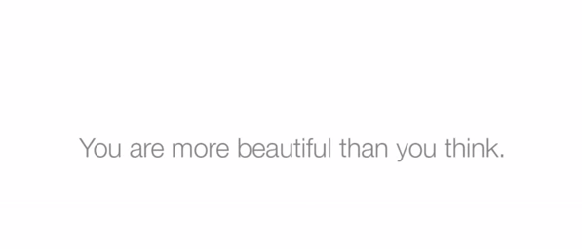

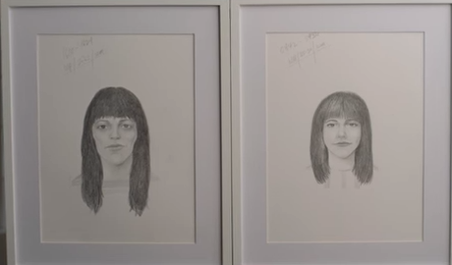

Project 1: Art Statement

Problem: Do you value other people’s opinion of you?

Video: <https://www.youtube.com/watch?v=XpaOjMXyJGk>

My project is about people, sometime we feel smaller in someone’s heart, sometimes the opposite because we know they would value us.

Feelings are such a mystery, I feel the more you want to control it, more like you are going to lose it. It’s like you cannot hold sands in your hands.

So this piece is compare of the image that the person herself and also her from other people’s perspective.

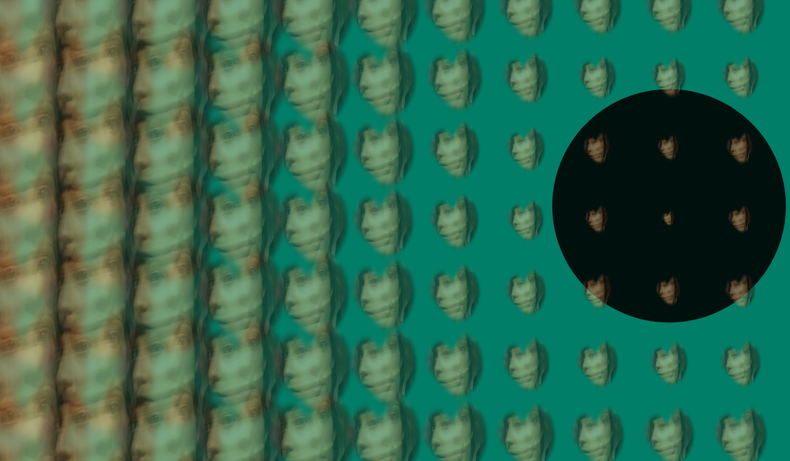

Notes:

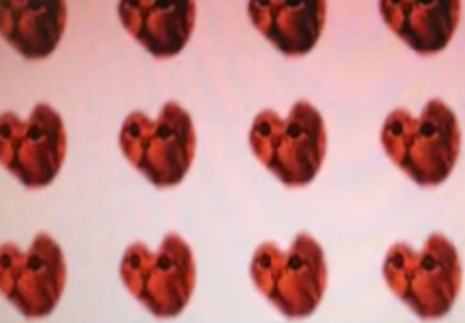

(This is the version 1 I made by using Alpha mask)